### Step 1 - Logging in

1. Click the provided cluster link.
2. If you get a warning similar to “Your connection is not private”, then click ***advanced***:

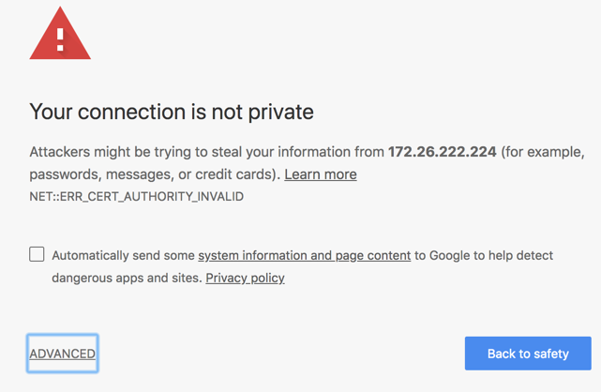

And then click ***proceed to <some IP address>***:

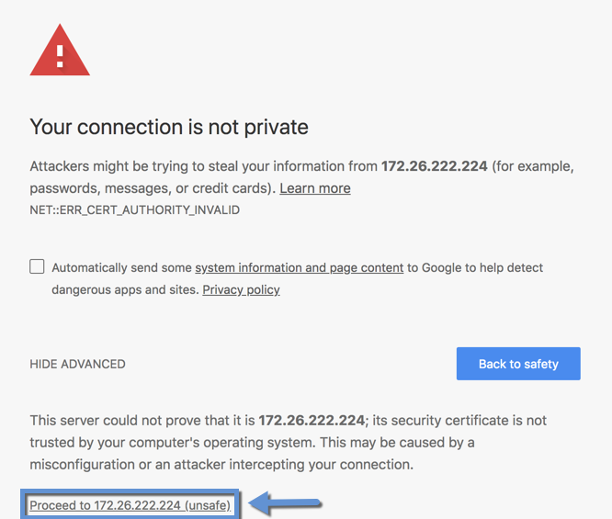

Use your selected user/password combination in the spreadsheet & click **Sign In**:

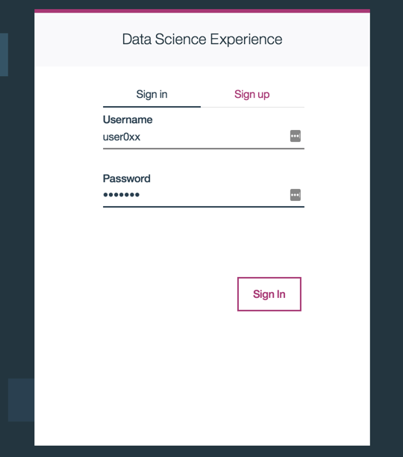

### Step 2: Creating Projects

Click ***Create project*** in the top right-hand corner drop-down menu:

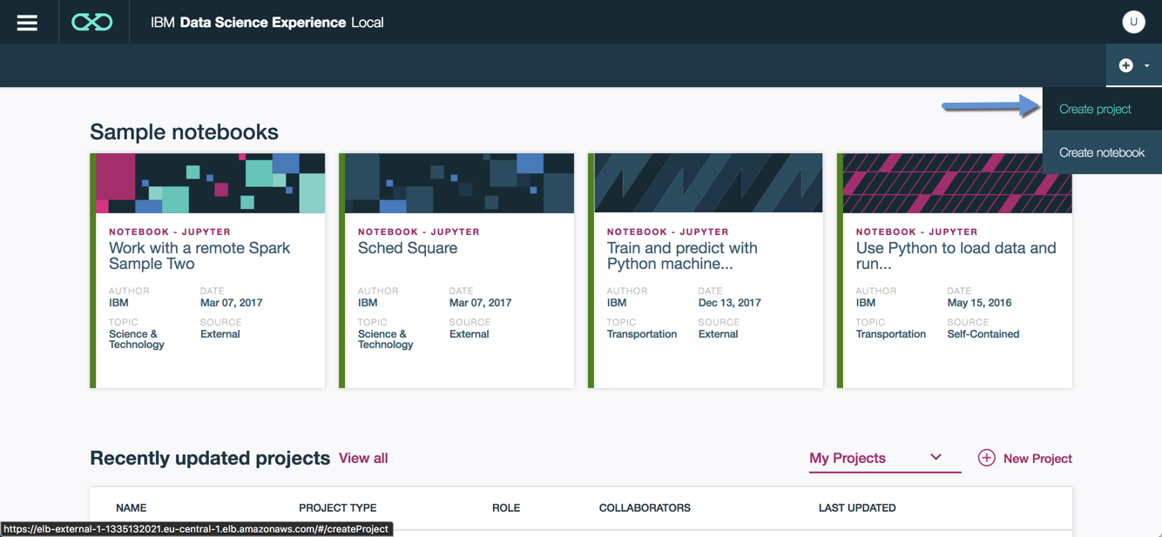

Create a project with unique name by appending your username at the end, e.g. Spark_Crash_Course_Project_user001:

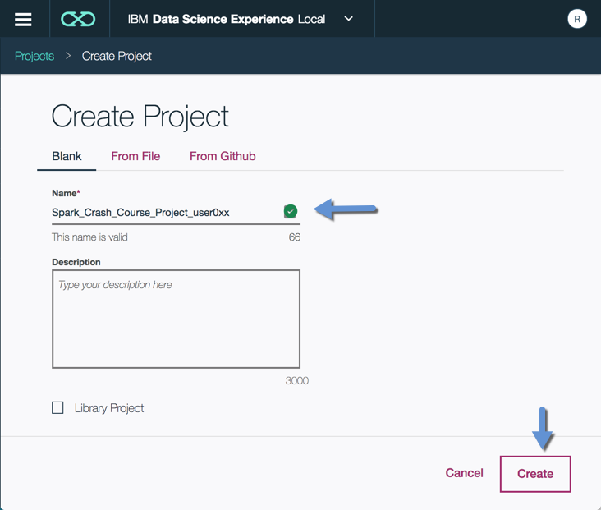

### Step 3 - Importing Notebooks

Click on **Assets**:

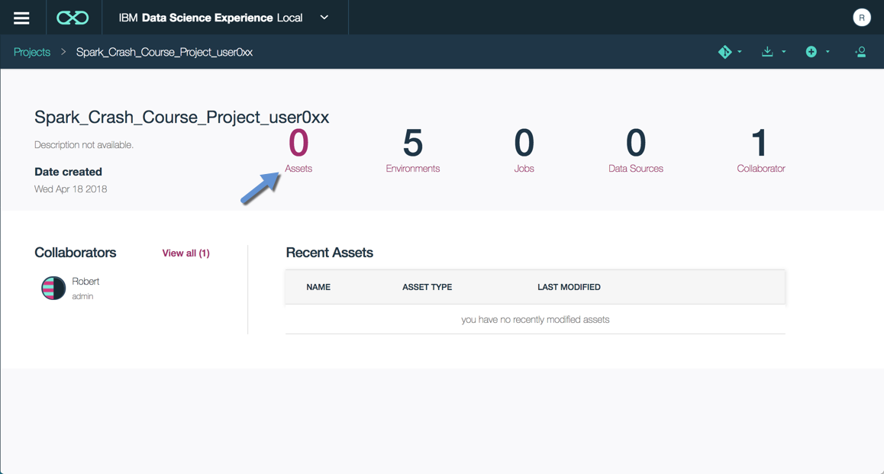

Click **add notebook**:

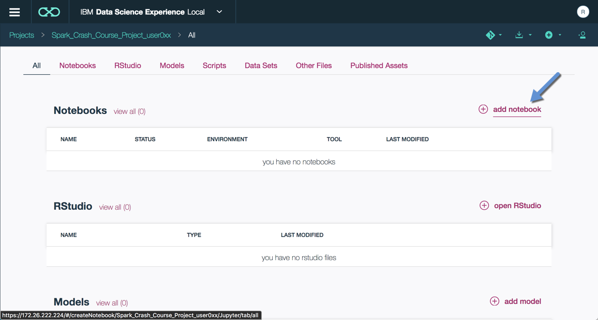

1. Select **From URL**,
2. type name **Spark_in_5_min**,
3. In **Notebook URL** paste the following: [**https://raw.githubusercontent.com/roberthryniewicz/zeppelin-notebooks/master/DWS-Berlin-2018/Spark-in-5-min-Berlin-CC.json**](https://raw.githubusercontent.com/roberthryniewicz/zeppelin-notebooks/master/DWS-Berlin-2018/Spark-in-5-min-Berlin-CC.json)
4. In **Environment** select **Zeppelin with Anaconda2, Python 2.7**
5. Click **Create**

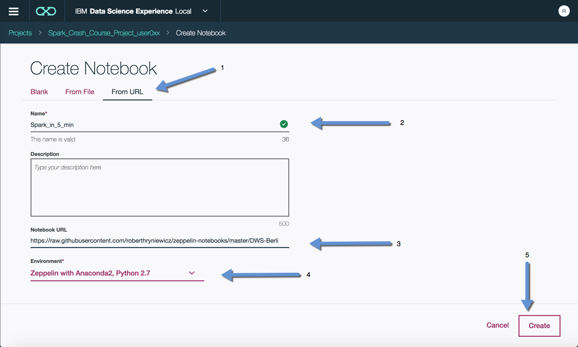

After a minute or two a Zeppelin notebook should load which will look like this

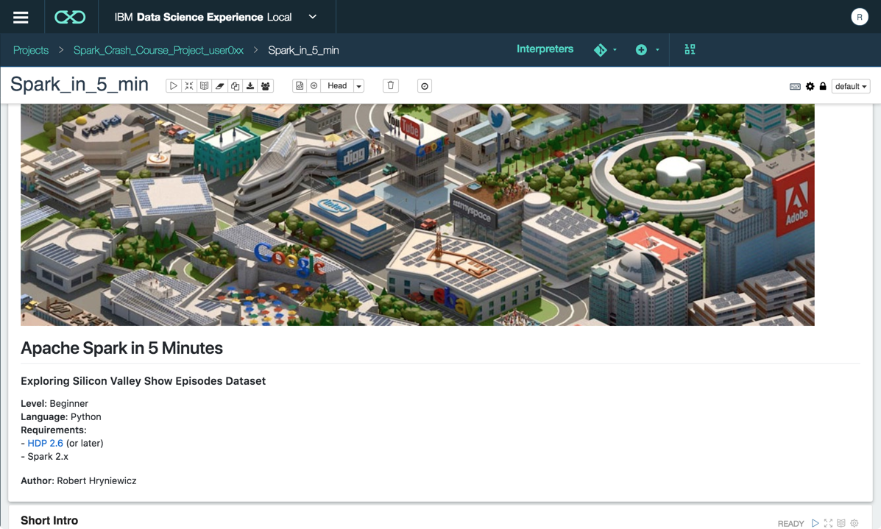

Follow the notebook to complete the lab.